Structural equation modeling (SEM) is a statistical tool designed to assess models depicting relationships between latent and observed variables and/or constructs. SEM uses an iterative method involving model specification, identification, estimation, assessment of fit, and model respecification (if necessary) (Hoyle, 2011; Kline, 2015). SEM is capable of testing theories, mediation or indirect effects, group differences, longitudinal models and nested models with multiple levels
SEM is abstractly a simultaneous, statistical compilation of multiple regression and confirmatory factor analysis techniques (Hoyle, 2011; Kline, 2015). Testing the relationships between constructs, plus overall model fit involves consideration of covariance matrices and multiple, multiple regression equations. Similarly, confirmatory factor analysis involves determining covariance relationships between observable variables and the influence, via regression weights, on the latent variables (Cohen et al, 2013).
SEM is able to test for direct effects and indirect effects (Kline, 2015). Direct effects indicate a relationship between two variables, in which one variable (Y) acts upon a second variable (X) without any intermediating variables (Y X) (Cohen et al, 2013). Alternatively, indirect effects is the relationship between two variables, in which a third variable intervenes. In the case of mediation, an independent variable influences move through a middle variable (mediating variable), before influencing the dependent variable (Y M X). Mediation is a common indirect effect tested within causal modeling (Cohen et al, 2013; Kline, 2015). Testing mediation and determining the degree of mediation is an increasingly common practice within SEM.
Structural Equation Modeling Simulations
Bentler & Speckart (1979) “Models of Attitude-Behavior Relationships”
In 1979, Bentler and Speckart used maximum likelihood, SEM method to test three competing mediation models depicting relationships between attitude and behavior. Bentler and Speckart wanted to test the theory of reasoned action model (a full mediation model) in comparison to two partially, mediated models (Ajzen & Fishbein, 1977). Bentler and Speckart collected survey responses on two occasions measuring attitude, subjective norms, past behavior, and behavioral intentions. On the second occasion, they collected a behavioral measurement.
The first model illustrated the theory of reasoned action, proposing that the indirect effects of attitude and subjective norms on behavior are fully mediated by behavioral intentions, depicted:
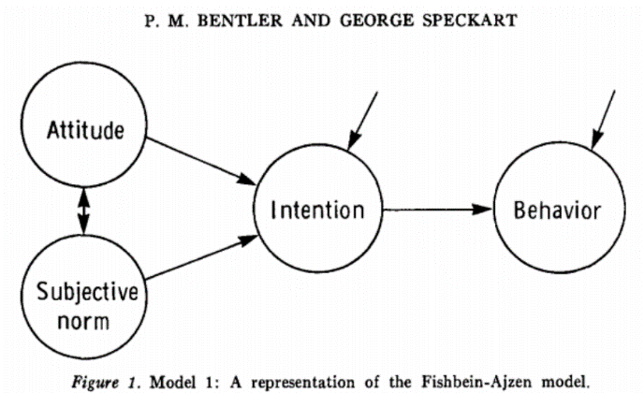
The second model posited the same relationship between subjective norms, behavioral intentions, and behavior. However, it also predicted the partial mediation of behavioral intentions for the effect of attitude on behavior. It also predicted a direct relationship between attitude and behavior, depicted below:
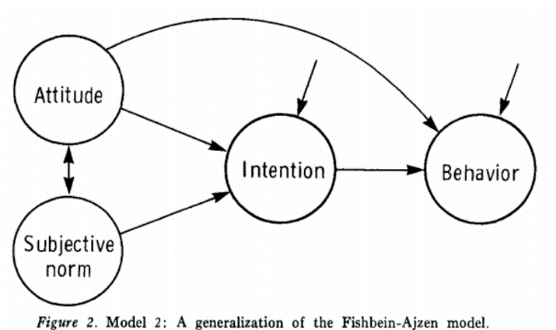
The third model employed the same predictions as the second model, but introduced a new latent variable, past behavior (Behavior I). Model 3 predicted the complete mediation between subjective norms and behavior via intention and the partial mediation of attitude on behavior via intention. Model 3 also proposed partial mediation of past behavior (Behavior I) on behavior (Behavior II) via behavioral intention (Intention), depicted here:
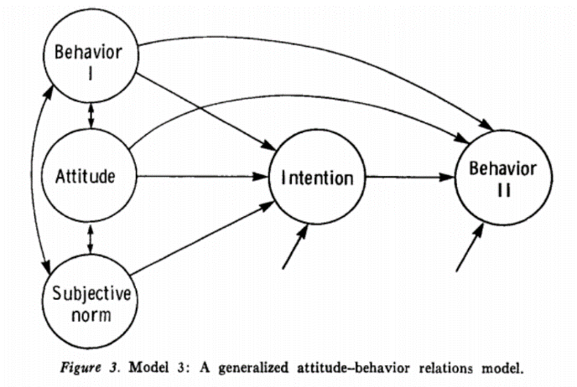
Bentler & Speckart (1979) Results
First, Bentler and Speckart conclude that the factor loading appear precise, as the regression weights associated with each observed variable is high and the error variances are relatively moderate to low. To determine if mediation occurred, Bentler and Speckart conducted numerous chi-square goodness of fit tests comparing variations of Model 2 and 3. Significant results indicated a better fit, and supported the importance of models implementing the mediation of the past behavior and behavior relationship via intention.
Simulating Data
To explore the nuances of SEM, I choose to simulate three specific data sets. The sample used in Bentler and Speckart was 228 students out of approximately 3500 undergraduate students enrolled at UCLA, in 1979. I employed a random number-generating algorithm to mimic random selection.
First, I created a data set representing the complete absence of any variable relationships (e.g. not even attitude influences behavior!). This sample consisted of 228 genuinely random, normally distributed responses. For the second and third data sets, I wanted realistic replications of the 1979 results. Bentler and Speckart (1979) concluded the Model 3 provided the best fit for their data. Thus, I used the parameter estimates from Bentler and Speckart’s analysis of alcohol consumption from the application of Model 3. In order to reconstruct the data, I began by generating a normally distributed number for one of the dependent variables. Since the relationship between variables was revered during data simulation (i.e. predicting IV values based upon DV values), I inverted the regression weight. Thus, if the beta weight for predicting a dependent variable (behavior) from an independent variable (attitude) is 25/100, the dependent variable was multiplied by the inverted regression weight 100/25. I then introduced standardized, normally distributed error for each latent variable.
To construct the observed variables, I used the parameter estimates provided and score composition equation for confirmatory factor analysis using regression weights. I calculated the mean associated with each latent variable. I used the latent variable mean as a ‘grand mean’ for each observed variable means. I then used the observed variable means to calculate a variety of related scores for all observed variables (Bollen & Pearl, 2013):
X1 = Mean_X1 + Beta_Weight_X1*(Attitude)+Error
The conceptual, calculative differences between the second and third population are the dependent variable used as initial value: the second population simulated latent factors as functions of the intention dependent variable (Intention); the third population simulated latent factors as a function of the behavior dependent variable (Behavior II). The second data set created latent factors attitude, subjective norms, and past behavior using the regression weights associated with the mediating variable, intention. This serve to conceptualize how SEM behaves when there is a strong relationship between the mediator variable and independent/dependent variables within a model. The third data set created latent factors attitude, past behavior, and intention using the regression weights associated with the final, dependent variable, behavior. This serve to conceptualize how SEM behaves where there is no mediation between two of the ‘mediated’ factors (attitude and past behavior). I will refer to these data sets as random, mediated, behavior-based.
SAS CALIS
For this analysis, I used PROC CALIS in the SAS software program. CALIS is designed for modeling causal relationships, plus confirmatory factor analysis. The maximum likelihood …. Is the default method in CALIS. The model was created using the PATH language (e.g. attitude <--- X1). This tool inferred latent variables, observed variables, and direction based upon the data and PATH statements.
Assessing Model Fitness
A number of indices exist to determine the fitness of a proposed model. These indices fall into two difference classes (Hoyle, 2011): 1) absolute fit 2) relative fit. Indices of absolute fit looks at the model’s ability to reproduce the covariance matrices (Kline, 2015). In other words, how does the estimated covariance matrices suggested by the model relate to the observed covariance matrices produced via the analysis of the collected data. Common absolute fit indices include model chi-square, standardized root mean square residuals (SRMSR), adjusted goodness-of-fit index (AGFI), and root mean square error of approximation (RMSEA).
Indices of relative fit look at the theoretical model in comparison to a null or baseline model (Hoyel, 2011; Kline, 2015). Common relative fit indices typically range from zero to one with results greater than .90 indicating good-fit. The Bentler comparative fit index and Bentler-Bonett normed fit index are examples of relative fit indices.
Fit indices can be sensitive and/or have limitations to their use. Thus, the cutoff values associated with fit indices differ depending upon their nature. Bentler and Bonett (1980) wrote, “experience will be required to establish values of the indices that are associated with various degrees of meaningfulness of results” (p. 600). As this is my first experience with SEM, I will defer to Hu and Bentler’s (1999) article outlining cutoff criteria for fit indices and the subsequent conclusions drawn in regard to model fitness.
Indices of Fitness: Chi-Squared Goodness of Fit
Chi-squared is the most popular, global fit statistic used in SEM. One of the reasons for chi-squares popularity with SEM is that it is the only inferential, statistical test for assessing model fitness (Barrett 2007). Chi-square is has limitations associated with its application to structural equation models (Bentler & Bonnet, 1980; Kline, 2015). Sample size influences the power and result of chi-squared. With small sample sizes, chi-square lacks the power; however, with larger samples chi-square tests are more likely to yield significant results.
Further, in SEM, chi-square will yield non-significant results if the model is ‘a good fit’. If accurate, this non-significant chi-square value ‘indicates’ little difference between the covariance structure of the model and the covariance structure of the observed data. Commonly known, trying to prove/accept the null hypothesis is not a good practice, as it skews the logical behind null hypothesis significance testing (Bentler & Bonnet, 1980).
The chi-squared goodness of fit results differed across models and simulated data sets. As chi-square goodness of fit is a null hypothesis significance test, I will defer to a p < 0.05 as indicating a significant difference between the implied covariance structure (insinuated by the model applied) and the obtained covariance structure (derived from the simulated data set). The application of Model 3 and Model 1 on the mediated data set yielded non-significant results. These results indicate no significant difference between the implied covariance matrix in the model and the obtained covariance matrix in the data set, implying both models fit the mediated data set.
Additionally the applications of all models (1, 2, 3) on the random data set yielded non-significant results. These results indicate that these models fit the simulated data set appropriately. These non-significant chi-square results obtained from analysis of the random data set are concerning. The random data set contains no causal relationships between variables, thus we know this models cannot accurately depict the random data set. With inexperienced users, these results could lead a researcher to, incorrectly, assume that the model applied fits the data appropriately.
Alternatively, the application of Model 2 to the mediated data set, plus the application of all models (1, 2, 3) to the behavior-based data set, yielded significant results. These indicate that the implied covariance matrices of each model differs from the obtained covariance matrices for their applied data sets and that these models do not fit their respective data sets.
Indices of Fitness: Standardized Root Mean Square Residuals (SRMSR)
The standardized root mean square residuals (SRMSR) is an additional measure of absolute fit. As the name implies, this measure looks at the residuals between the model covariance matrix and the sample covariance matrix (Hooper, Coughlan, & Mullen, 2008; Kline, 2015). The standardized version was created, due to the varying numerical scales employed in research (e.g. 1-5, 1-7, 1-10) (Kline, 2015). The typically acceptable cutoff value for SRMSR is 0.08. An SRMSR of less than 0.08 indicates a well-fitting model (Hu & Bentler, 1999). However, other researcher has suggested using a 0.05 cutoff value instead (Hooper, Coughlan, & Mullen, 2008).
When considering 0.08 as an appropriate cutoff value, all applications of Model 1, Model 2, and Model 3 fit each of the three simulated data sets (random, mediated, behavior-based). However, when employing a more stringent cutoff of 0.05, these conclusions change.
With a 0.05 cutoff value, applications of Model 1, Model 2, and Model 3 deemed a good fit for the mediated data set. Further, the application of Model 1 on the random data set appeared to be a good fitting model. However, once again, this is incorrect as the data set simulated is complete random. The application of all models (1, 2, 3) are not deemed to fit the behavior-based simulated data set. The same is true for applications of Model 2 and Model 3 to the random data set.
Indices of Fitness: Adjusted Goodness of Fit Indices (AGFI)
The adjusted goodness of fit (AGFI) indices is a less widely used, classic absolute fit index (Hooper, Coughlan, & Mullen, 2008; Hu & Bentler, 1998, 1999). Similar to the goodness-of-fit index, AGFI alters based upon degrees of freedom. Application of AGFI is sensitive to sample size, resulting in a sometimes, bias estimate if the sample size exceeds 200. Further, AGFI proves better at assessing fit for simpler models, but is less reliable when assessing fit for large models. An AGFI of 0.9 or higher indicates a good fitting model.
Within the simulated data, almost all of the AGFI’s indicated a good model fit. The application of Model 3 and Model 1 on the behavior-based data set were the only models that failed to indicate good fitting models. As the sample size was larger than 200, this indices may be yielding bias results, considering that all three models were deemed appropriate for the random data.
Indices of Fitness: Root Mean Square Error of Approximation (RMSEA)
The root mean square error of approximation (RMSEA) is a measure of absolute fit. Like all previous measures, RMSEA considers how the entire model fits the data set. One of the most desirable qualities of RMSEA is its consideration of the number of parameters estimated within a model. The cutoff value for RMSEA is < 0.06. RMSEA indicates a better model-fit as it approaches zero (Hu & Bentler, 1999).
Within the simulated data, the application of all models (1, 2, 3) to the mediated data set indicate appropriate fitness. Thus, all models fit the mediated simulated data set. Additionally, the application of Model 3 and Model 2 to the behavior-based data set indicated an appropriate fit. The application of Model 3 to the random data set also indicate that the model fits the data. Again, this fit index is concerning as the data simulated was completely random.
The RMSEA indices for applications of Model 2 and Model 1 on the random data set could not be calculated. Additionally, the application of Model 1 on the behavior data set indicated that Model 1 does not fit the behavior-based data set.
Indices of Fitness: Bentler Comparative Fit Index (BCFI)
The Bentler comparative fitness index (BCFI) is a relative fit index, meaning the comparative approach differs from the absolute fit indices previously discussed (Bentler, 1990; Hu & Bentler, 1999). Instead of comparing the implied, model covariance matrix to the obtained covariance matrix, as global fit indices do, BCFI compares the model to a null model. The null model assumes that the observed variable variances are uncorrelated (Bentler, 1990). The covariance matrices for the proposed model and the null model are compared with the observed covariance matrices, represented by a chi-square value. Obtaining a BCFI of 0.95 or higher indicates that the model fits the data analyzed (Bentler 1990, Hu & Bentler, 1998, 1999). Within the simulated data sets, BCFI indicated that each model (1, 2, 3) fit the mediated simulated data set and the behavior simulated data set.
It is important to note, BCFI and RMSEA are the only indices that indicated issues with the random data set. Within the random simulated data set, applications of any model yielded a BCFI of zero or no value at all. Due to the incorporation of a null model, I believe BCFI was able to detect complete lack of relationship within the random data set, as the data set should perfectly fit a null model. Similarly, RMSEA yielded no value on the random data sets. The BCFI and RMSEA are the only indices that may alert inexperienced users to major issues with their model fit.
Chi-Square Difference Test & Considering the Simulation
As application of Model 1 and Model 3 yielded non-significant chi-square results within the mediated data set, I conducted a chi-square difference test to determine if one model ‘fit’ the data better (Kline, 2015). The chi-square difference test indicated no significant difference between the application of Model 1 or Model 3 on the mediated simulated data set, χ² (2, N = 33) = 24.98, p = 0.16.
Pros and Cons of Mediation Analysis in SEM
Considering this exploratory simulation, I feel that structural equation modeling offers a number of benefits to social scientists. One of the most profound benefits of SEM is the ability to establish and analyze complex relationships with multiple dependent variables. This is a positive contribution for mediation analyses, as SEM can statistically handle more complex, mediated relationships. It also allows social psychologists to investigate the mediation of latent constructs, such as attitude. Further, SEM allows for confirmatory factor analysis, which can aid in detecting mediating variables. However seductive these benefits may be, SEM can be difficult to use and results can be difficult to interpret, meaningfully.
A dangerous issue with SEM is specification of a mode a priori. Model specification is a big step in mediation analysis and SEM is unable to detect differences in directionality (e.g. X W Z Y vs X Z W Y) (Kline, 2015). Thus, if two variables mediate a relationship, it is up to the experiment to investigate properly.
Within the mediated simulated data set, SEM, SRMSR, AGFI, RMSEA, and BCFI all concluded that Models 1, 2, and 3 fit the data. This indicates that these statistics are good at detecting a relationship between mediated variables. However, these tools lack precision. If a researcher wanted to move forward with these results, to explore the mediating variables further, they would be unable to determine which model demonstrated a more accurate relationship between these variables. Within the behavior-based data set, the fit indices conclusions varied. For example, all values of chi-square indicated a significant difference between the data set and each model. However, all RMSEA values indicated a good fit. Thus, interpreting the results from SEM becomes increasingly difficult as the complexity of the variable relationships increases.
Finally, two caveats, should be considered when using SEM to conduct mediation analyses: 1) temporal precedence, 2) the final goal of a mediation analysis. Within any empirical analysis, temporal precedence of variables is necessary to infer causation. However, Kline (2015) noted, “most studies in the mediation literature are based on cross-sectional designs where all variables are” measured at once (p. 204). Without temporal precedence, the use of SEM and other mediation analysis techniques are inappropriate. However, if data collection occurs properly with time-based constraints, as suggested by Tate (2015), then using SEM to determine mediation may be suitable (Tate, 2015).
Within psychology, many mediation analyses seek to determine sequential influences on human behavior. As Trafimow (2014) pointed out, much research in psychology is conducted at the group level. At best, this provides a ‘general consensus’ (X M Y) for some forms of human behavior. However, if a psychologists wishes to manipulate the behavior (e.g. increase number of social interactions) on the individual level, the mediating variables may not follow the ‘general consensus’. Perhaps, there is a third variable impacting this individual, which the psychologists failed to capture (X L M Y).
A number of SEM applications focus on mediation. SEM has the capability to detect indirect effects within a data set, however these indirect effects can be difficult to interpret and do not necessarily equate to real mediation. As the simulation illustrated, it is possible to obtain multiple indices of model fitness, when there is an inherent lack of relationship between variables. The complex nature of variable relationships and the stringent requirements for SEM should deter inexperienced researchers from implementing SEM without proper training or guidance.

References
Ajzen, I., & Fishbein, M. (1977). Attitude-behavior relations: A theoretical analysis and review of empirical research. Psychological Bulletin, 1977, 84, 888-918.
Barrett, P. (2007). Structural equation modelling: Adjudging model fit. Personality and Individual Differences, 42, 815-824.
Bentler, P. M. (1990). Comparative Fit Indexes in Structural Models. Psychological Bulletin, 107, 238-246.
Bentler, P. M. & Bonett, D. G. (1980). Significance test and goodness of fit in the analysis of covariance structures. Psychological Bulletin, 88, 588-606.
Bentler, P. M., & Speckart, G. (1979). Models of attitude–behavior relations.Psychological review, 86, 452.
Bollen, K. A., & Pearl, J. (2013). Eight myths about causality and structural equation models. In Handbook of causal analysis for social research (pp. 301-328). Springer Netherlands.
Bullock, J. G., Green, D. P., & Ha, S. E. (2010). Yes, but what’s the mechanism? (Don’t expect an easy answer). Journal of Personality and Social Psychology, 98, 550-558.
Cohen, J., Cohen, P., West, S. G., & Aiken, L. S. (2013). Applied multiple regression/correlation analysis for the behavioral sciences. Routledge.
National Center for Educational Statistics (2016). Undergraduate Enrollment. retrieved from: http://nces.ed.gov/programs/coe/indicator_cha.asp
Hooper, D., Coughlan, J., & Mullen, M. (2008) Structural Equation Modelling: Guidelines for Determining Model Fit. Electronic Journal of Business Methods, 6, 53-60.
Hoyel, R. H. (2011). Structural Equation Modeling for Social and Personality Psychology. Sage: CA, Thousand Oaks.
Hu, L. T. & Bentler, P. M. (1999). Cutoff criteria for fit indexes in covariance structure analysis: Conventional criteria versus new alternatives. Structural Equation Modeling: A Multidisciplinary Journal, 6, 1-55.
Hu, L. T. & Bentler, P. M. (1998). Fit indices in covariance structure modeling: Sensitivity to underparameterized model misspecification. Psychological Methods, 3, 424-453.
Kline, R. B. (2015). Principles and practice of structural equation modeling. Guilford publications.
Kline, R. B. (2015). The mediation myth. Basic and Applied Social Psychology, 37(4), 202-213.
Snyder, T. D. (1993). 120 years of American education: A statistical portrait. DIANE Publishing.
Tate, C. U. (2015). On the overuse and misuse of mediation analysis: It may be a matter of timing. Basic and Applied Social Psychology, 37(4), 235-246.
Trafimow, D. (2014). The mean as a multilevel issue. Frontiers in Psychology, 5, 180.
Appendix A
Path Diagram of Model 3 Results
(Bentler & Speckart, 1979)
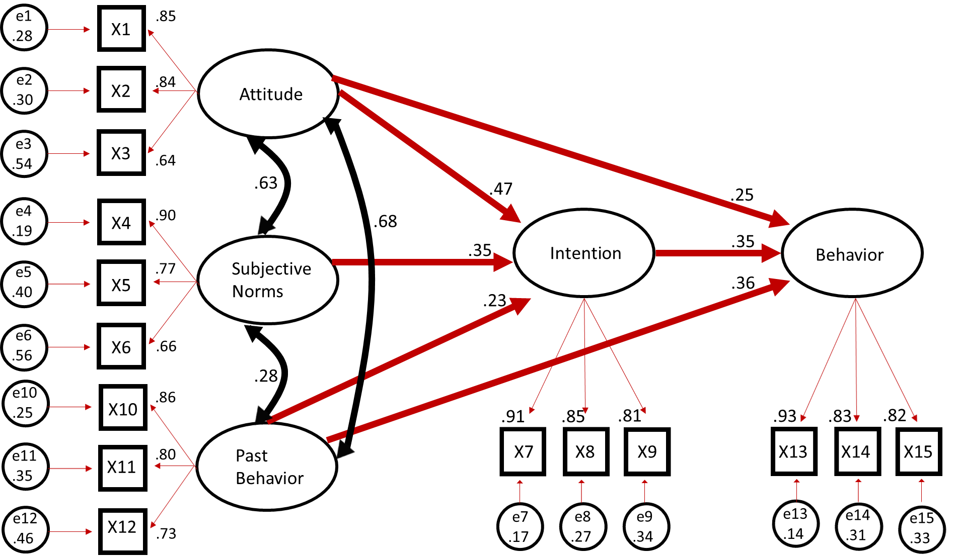

Appendix B
Model | Simulated  Data Set | χ² | Proposed Cutoff  p > 0.05 | Standardized Root Mean Square Residual | Proposed Cutoff  SRMSR < 0.08  or < 0.05 | Adjusted Goodness of Fit Index | Proposed Cutoff  AGFI > .9 | Root Mean Squared Error of Approximation | Proposed Cutoff  RMSEA < 0.06 | Bentler Comparative Fit Index | Proposed Cutoff  BCFI > .95
3 | Mediated | 102.56* | 0.1374 | 0.0.449* | < 0.08 | 0.9223* | > .9 | 0.0270* | < 0.06 | 0.9953* | > 0.95
2 | Mediated | 72.5783 | 0.0466 | 0.0458* | < 0.08 | 0.9267* | > .9 | 0.0389* | < 0.06 | 0.9895* | > 0.95
1 | Mediated | 72.5986* | 0.0561 | 0.0458* | < 0.08 | 0.9280* | > .9 | 0.0375* | < 0.06 | 0.9900* | > 0.95
3 | Behavior | 129.7711 | 0.0025 | 0.0560* | < 0.08 | 0.8989- | < .9 | 0.0457* | < 0.06 | 0.9919* | > 0.95
2 | Behavior | 82.4925 | 0.0075 | 0.05319* | < 0.08 | 0.9143* | > .9 | 0.0482* | < 0.06 | 0.9932* | > 0.95
1 | Behavior | 120.1107 | <.0001 | 0.0607* | < 0.08 | 0.8811- | < .9 | 0.0722 | > 0.06 | 0.9845* | > 0.95
3 | Random | 93.9945* | 0.3114 | 0.0586* | < 0.08 | 0.9292* | > .9 | 0.0173* | < 0.06 | --- | --
2 | Random | 48.4053* | 0.6891 | 0.0527* | < 0.08 | 0.9503* | > .9 | -- | -- | -- | --
1 | Random | 48.4916* | 0.7199 | 0.028* | < 0.08 | 0.9511* | > .9 | -- | -- | -- | --
Table of Goodness of Fit Indices

The syntax used to generate all three populations is available upon request.
The population size is an estimate based on the current proportion of U.S. undergraduates enrolled at UCLA and the previous portion of U.S. undergraduates enrolled in an undergraduate program in 1979. (National Center for Educational Statistics 2016; Snyder, 1993)
A path diagram of the Model 3 with corresponding regression weights is located in the appendix.
The syntax and output used for each SAS analysis is available upon request.
A Goodness-of-Fit table containing exact indices and cutoff values in the appendix.

